Kebing Li

AS151

Writing Assignment (Final Draft)

5.13.2016

Wear a cosmological lens!

Kebing Li

Imagine yourself standing somewhere in our huge and seemingly endless universe and looking for your best friend, who is, for some reason, generating some lights and waving to you on a planet far away from where you are. You clearly know that no matter how great your eyes are you are not able to see him. But the clever you happen to know some astronomy knowledge and know that there are many “natural lenses” in our universe that can be used as your “cosmological lenses” to help you see your friend. Therefore, after strict calculation and careful modeling, you find an appropriate angle and could finally see a distorted image of your friend. You are really happy.

This little story tells us two important things. First, do not hang out on planets so far from your friends’ stars. It is really hard for them to see you even if you can generate lights and wave your hands as hard as you can. And second, if we don’t bother with the effects of some distortions, we can indeed see the images from very distant light sources by using some “natural lenses” provided in the universe. Hope this property inspires you… Yes! You could not only use these “natural lenses” to find your friends but also to observe and detect extremely distant stars!

In fact, the “natural lenses” we kept talking above has a legal name in astronomy, gravitational lensing, and it is “unsurprisingly” one of the most crucial methods to help people understand and detect distant objects.

The idea of gravitational lensing was most commonly related to the great Jewish scientist Albert Einstein and his famous general relativity theory; however, the origin or this theory can be even traced back to the Newtonian gravity theory, by using which people also successfully predicted the gravitational lensing effect, only with a different size of deflections.

The name of this effect, gravitational lensing, came from the fact that massive objects behave similarly as the normal convex lenses we played with in high school. Hopefully, we could still remember high school physics that convex lenses converge lights to their focal points. This idea can be extended and apply in the universe: If the light from a distant background object passes through or near a massive foreground object, the light will appear to follow a curved path to form the images of the background object, just like a massive “cosmological lens” deflects the light.

Although the gravitational lensing effect is hard to capture and complicated to calculate, its basic idea is easy for us to understand. Like what I described above, we can simply model this astronomical phenomenon by high-school optic experiments of convex lens. The graph below provides a basic sense of how the light is deflected by a massive object (or simply a convex lens).

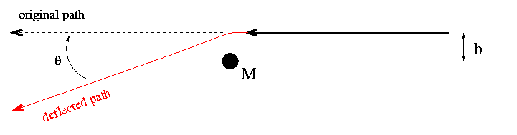

**The Simple Convex Lens Effect[1]**

In this “simple convex lens effect” graph, M represents a massive object in the universe that has similar properties as a large optic convex lens. The right end of the black arrow is the light source (background object) that generates the lights, which has a vertical distance “b” from the object “M”. The straight dashed line shows the original path the light would travel if nothing affects it. However, according to Einstein’s theory of general relativity, massive objects will create strong gravitational fields that curve the “spacetimes” around the objects. Therefore, when the light passes the massive object, it will follow the curvature of the “spacetime”, which turns out making the light deflected and leading it to move along the red “deflected path”.

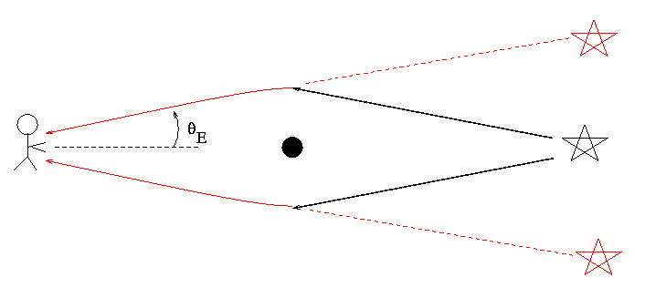

**Simple Convex Lens in Universe[2]**

After understanding the basic idea, we can move closer to the reality. The graph above roughly shows the condition of the gravitational lensing effect in the universe. Let’s recapture the story about your friend and you at the beginning of the article. Under that circumstance, if you can set an angle so accurate that your friend’s star (the black star) lines up perfectly with the massive “natural lens” (black-colored) you choose, the “natural lens” can bend the light generated by your friend, which would otherwise go far above and below you. In fact, this deflection of light will affect what you see. In your view, the light will seem to come from an angle theta above and theta below the actual position of your friend, which will lead you to see a ring of light surrounding the real position of him. (Shown as the graph below)

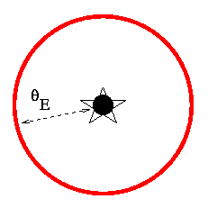

**Einstein Ring[3]**

The red ring shown above is called an Einstein ring and the radius theta is called the Einstein ring radius in memory of Albert Einstein, whose work significantly contributed to the development of gravitational lensing theory. After mathematical deduction, we could know that if you can find a “natural lens” that locates exactly half way between your friend’s star and your position, you could see your friend most clearly, i.e. the gravitational lensing effect reaches the strongest.

However, even if we could possibly calculate the accurate value of the Einstein ring radius, we might not have the opportunity to see a perfect Einstein ring throughout our life. If we actually did the mathematical calculation, we would see how small the angle theta would be. In fact, our technology so far has not reached the level to identify the gravitational lensing effect created by a single star; the only hope for us to discern this effect is when a galaxy, or many galaxies behave as the “natural lenses”. The nearly perfect Einstein ring people have discovered so far occurs in the jet of quasar MG1654+1346. The ring has a radius about 1 arcsec, which is about 2.8*10-4 degrees. This radius is relatively large comparing to other Einstein ring radius, as the “natural lens” is a spiral galaxy, but it is still impossible for non-experts to perceive. Now, you probably understand what I mean when I said, “how small the angle theta would be.”

Wait… the story does not end here. If everything is fine, then you could see an Einstein ring around your friend. But what if something is not as perfectly as you wish? For example, what if you cannot find an angle that makes your friend’s star perfectly line up with your chosen “natural lens”? The answer is that you cannot see a bright ring of light. But instead you may see some distorted and magnified versions of your friend. Or, you may see multiple images of your friend at one time. In the real world, these two possible cases are much more common because when something is called “perfectly”, it means almost impossible. A perfectly lining up pair of lensing object and lighting source is really hard to find.

After knowing a little bit about how gravitational lensing works, we can then talk about the three subtypes of gravitational lensing: strong lensing, weak lensing, and microlensing.

Strong lensing is a relatively simple idea and it is basically the effect leading to the distorted image of your friend.

Weak lensing happens when the lensing object is not that strong and the distortions of background objects are much smaller. It can only be detected by data analysis. Although this small effect is impossible to disentangle for an individual galaxy, weak lensing by gravity affects many galaxies in the same part of the sky in the same way. Therefore, by studying a large number of galaxies in a particular small part of sky and looking for alignments in their distortions, we can capture the main picture of the weak lensing effect. Even though it requires massive amount of work, weak lensing proves to be very useful in astronomy. It provides us a feasible way to measure and investigate the distribution of our cosmos, especially the distribution of dark matter, a hypothetical matter that is invisible to the entire electromagnetic spectrum. As we cannot directly observe the dark matter, we can analyze the quantitative effects of weak lensing and reconstruct the distribution of dark matter, as it has considerably large mass.

Microlensing is also a gravity effect, but it is not the same as strong and weak lensing. In this case, the “natural lenses” are called MACHOs (Massive Compact Halo Object). Black holes, white dwarfs and brown dwarfs all belong to MACHOs. The result of a microlensing is a significantly increase in brightness of a distant object. Therefore, it can be used to detect objects that emit little or no light, which allows astronomers to study objects no matter how faint they are, for example detecting exoplanets. And more importantly, it means you can see your friend even if he does not generate many lights.

The three types of gravitational lensing are defined distinctively, but all of them serve well to our understanding, study and research of our universe.

Generally speaking, gravitational lensing effect is a very modern and advanced comprehension to our universe but it closely relates to our lives as well. Usually when astronomers try to introduce people this idea, they will say that we people ourselves are “natural lenses” as well, and the “spacetimes” around us are also curved by our own gravities. This leads to an interesting argument that “the you in my eyes is not the real you.” Following this sense, it is valid to say, “There are a thousand of Hamlets in a thousand people’s eyes.” Think about this. Isn’t it really amazing that everything in the world is somehow related to this whole idea of gravity?

Looking up to the sky, thinking of the large scale of our universe and the tiny scale of our own humanities, it is really amazing to live in this world.

**References**

1. <http://astronomyonline.org/Cosmology/GravitationalLensing.asp>
2. <http://spiff.rit.edu/classes/phys240/lectures/grav_lens/grav_lens.html>
3. <http://w.astro.berkeley.edu/~jcohn/lens.html>
4. <http://www.darkenergysurvey.org/science/weaklens.shtml>
5. <https://en.wikipedia.org/wiki/Einstein_radius>
6. <http://baike.baidu.com/link?url=93kG_sGptP_uxTkuxL1WLjyPdeT2bX7DHs8hVxc6KrK6Kg5t6NbMUiQIMabAklOIua5r0Fi2Ivt7itKbdOShEq#3>
7. <https://en.wikipedia.org/wiki/Gravitational_lens>

1. http://spiff.rit.edu/classes/phys240/lectures/grav_lens/grav_lens.html
2. http://spiff.rit.edu/classes/phys240/lectures/grav_lens/grav_lens.html
3. http://spiff.rit.edu/classes/phys240/lectures/grav_lens/grav_lens.html